DATA MANAGEMENT SYSTEM

2 DMS PROJECT PHASE – I SPECIFICATIONS
2.1 Graphical User Interface

Enabling functionalities for DMS
- Re-naming the DMS database tables and columns
- Export data page’s project info div shall show from start time to end time records of corresponding project from the ‘product_data’ table
- Database ‘product_data’ table shall accommodate all different types such as 1.VLIFE-(mk1).csv, 2. VLIM-(mk1).csv, 3. VLIFE-(mk2).csv, 4. VLIM-(mk2).csv
- Create new “create-project” page
- Standard CSV file name for upload data into database

- DMS Database Tables and columns name

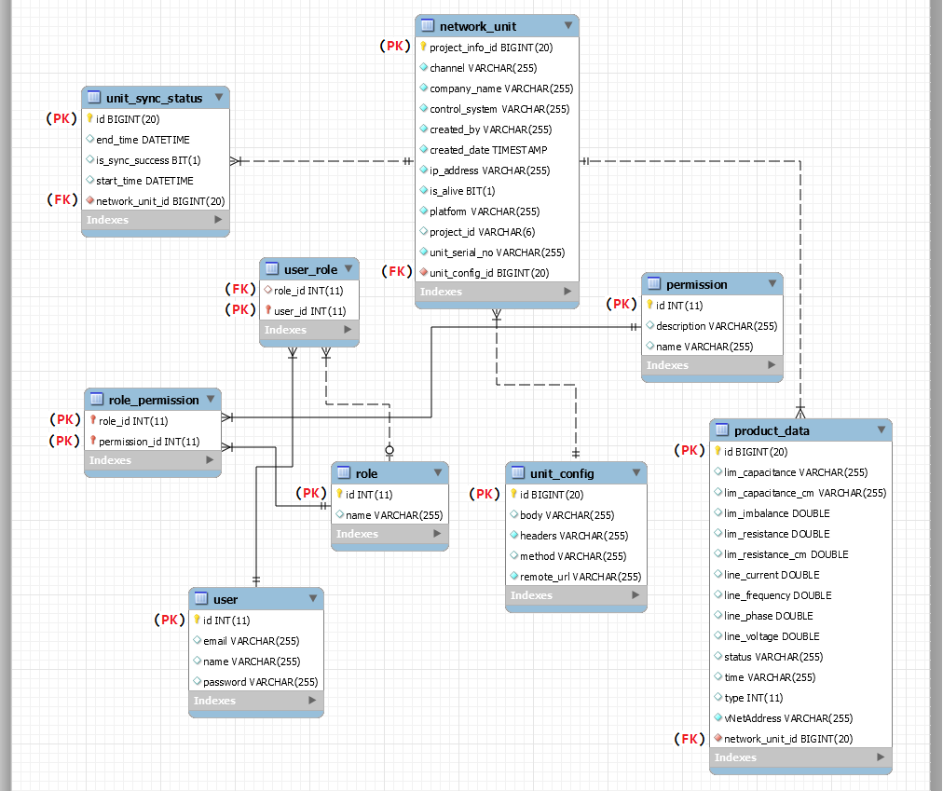
Figure 1: Present database structure

- Refer “Database-Table-Column-Names.doc” for detailed table names and column names

2. Export unit data
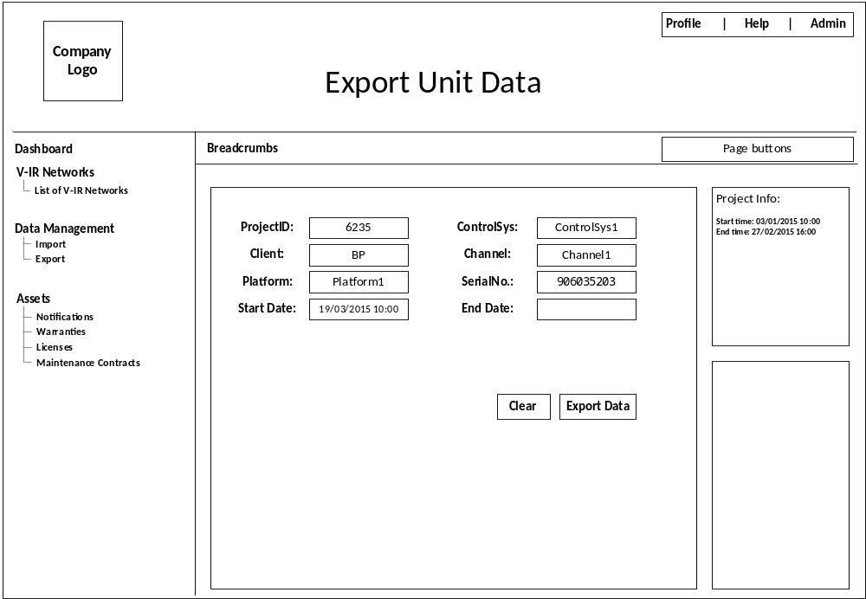
Figure 2: Export data page
Export data page;
- After selecting ProjectID, ControlSys, Client, Channel, corresponding available data’s start-date and end-date shall be shown in the “Project Info:” div so that when user make selection accordingly using DateTime picker.

3. Create project
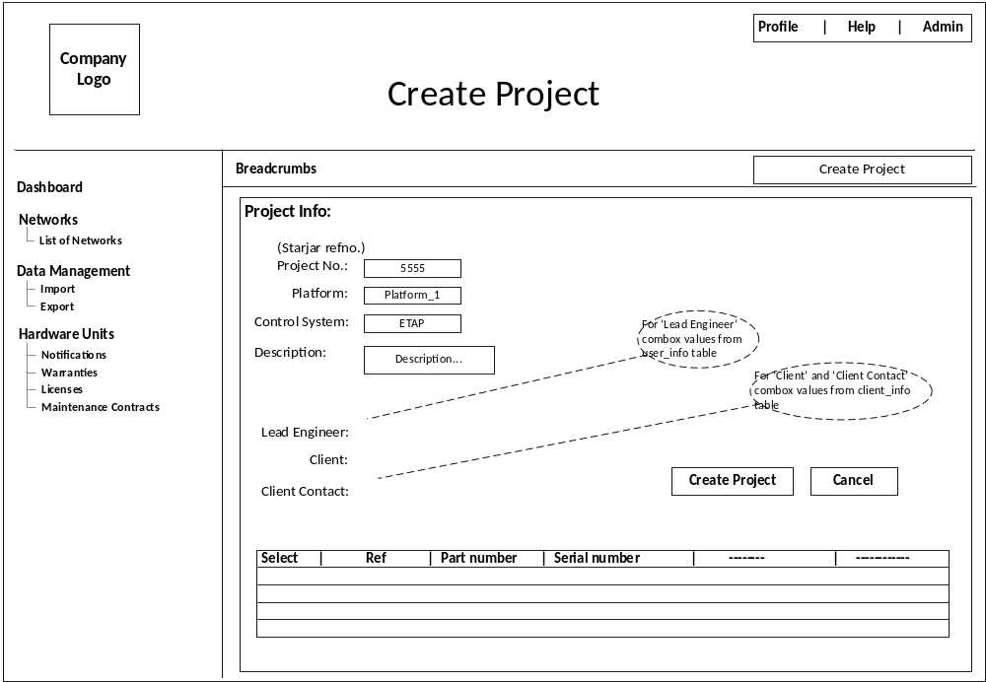
Figure 3: Create project page.
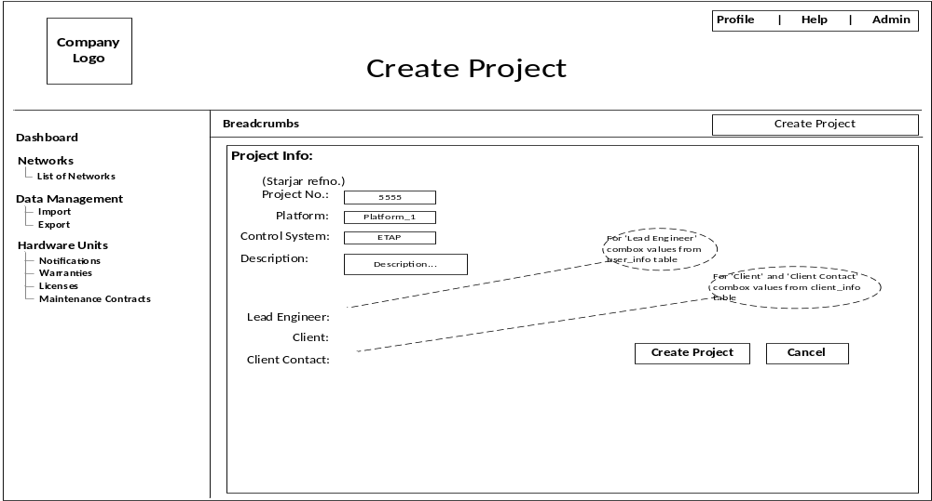
Figure 4: Create_project page with normal table on it.
Create project page;
- Instead of pop-up shall have separate page.
- First four textboxes 1. Project No. (Starjar Ref no.), 2. Platform, 3. Control System, 4. Description shall read the values from the user.
- Next three fields 1. Lead Engineer, 2. Client, 3. Client Contact shall have combobox and the values read from ‘user_info’ table and ‘client_info’ table respectively.
- Normal HTML Table should populate few values from the “network_unit” (present)/ “project_info” (proposed) tables, such as 1. ref_no., 2. part_no, 3. serial_no.
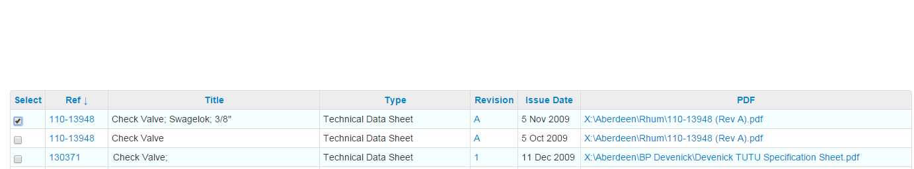
Select column shall have check box to select the particular row.
Note: Only displaying the values on the create_project page for now, creating a new project in the database will be done once the create_page is finalised.

4. Detailed graphing
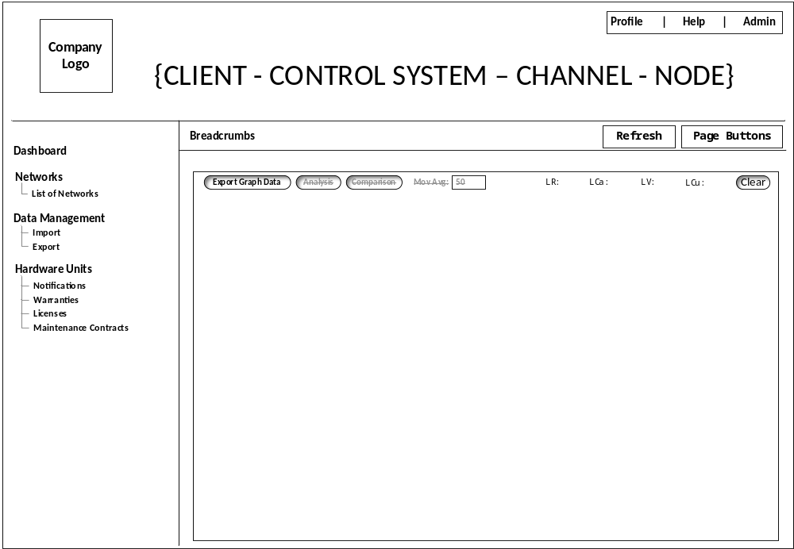
Figure 5: Graph page
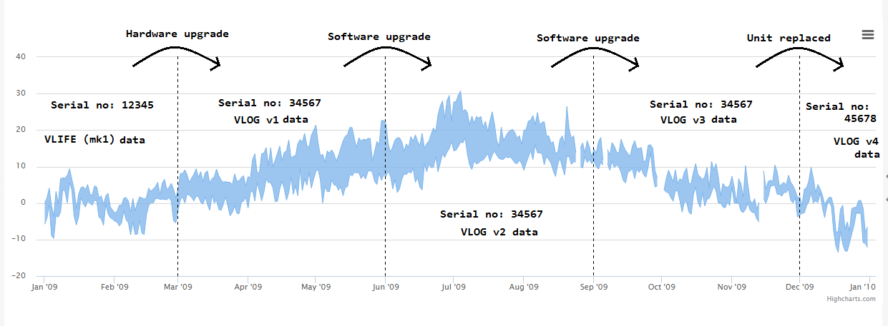
Figure 6: Graph view
Graph page;
- Remove the right side divs and bottom div to use full space for the graph.
- The graph should show the complete history data log of one particular project.
Typical scenario shown in figure 6:
  - From jan-09 to mar-09 The hardware unit is installed with vlife-(mk1) data log readings and assigned under the project ID 6617 with serial no. 12345
  - From mar-09 to jun-09 hardware upgrade with vlim-(mk1) data log readings and assigned under the same project ID 6617 with serial no. 34567
  - From jun-09 to sep-09 software upgrade with vlim-(mk2) data log readings and assigned under the same project ID 6617 with serial no. 34567
  - From sep-09 to dec-09 software upgrade with vlim-(mk3) data log readings and assigned under the same project ID 6617 with serial no. 34567
  - From dec-09 to ---- unit is replaced with vlim-(mk4) data log readings and assigned under the same project ID 6617 with serial no. 45678

5. Upload data
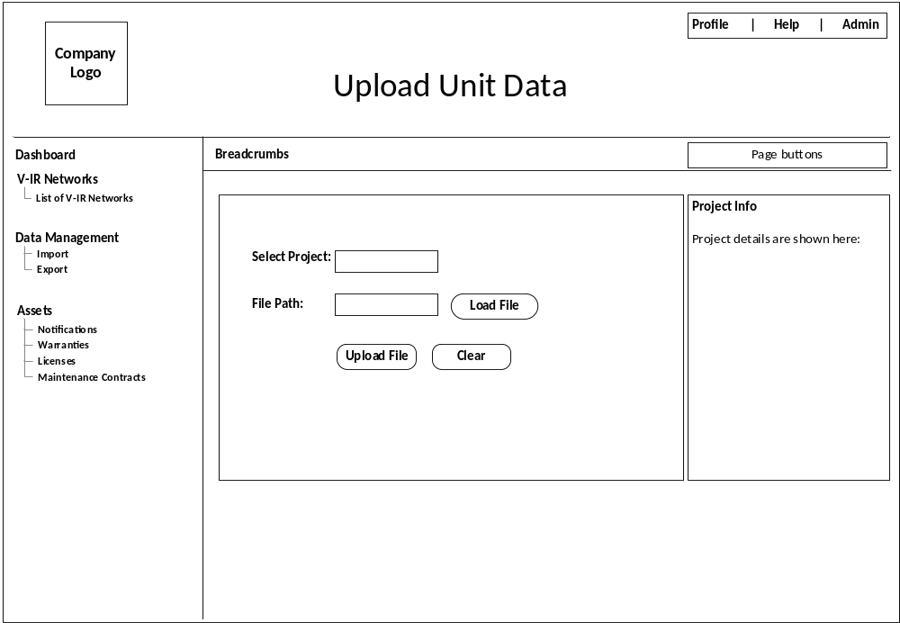
Figure 7: Upload data page

Upload page;
- The values shown in the tooltip, shall also display on the ‘project info’ div
- When upload file name should be in
<vlim-datalog>_SerialNumber_<yyyy-mm-dd>
format, irrespective of the VLOG types.
- After selecting the file, should check
  - File format (<vlim-datalog>_Serial Number _ (yyyy-mm-dd))
  - Check the file name’s serial number with ‘present_serial_no’ column in “project_history_info” table, if matches should append the all the data log histories under the project.

Sample files for testing:
- vlim-datalog_855703555_2015-01-01 is for vlife-(mk1)
- vlim-datalog_906035206_2015-02-01 is for vlim-(mk1)
- vlim-datalog_906035206_2015-03-01 is for vlim-(mk1)-Ty-3

